

UNIVERSITY OF BUEA
FACULTY OF ENGINEERING AND TECHNOLOGY
DEPARTMENT OF COMPUTER ENGINEERING
Internet and Mobile Programming
CEF440
TASK 5: UI Design and Implementation

GROUP MEMBERS

Names | Matricule
FONTEBO ACHAH | FE23A062
ANU ROLENCE AKEM | FE23A013
NEIL AMBAYI MPOCHE | FE23A105
OTANG JANICE | FE23A134
ASHU ALBERIC | FE23A015

Course Instructor
Dr. Valery Nkemeni

1. Introduction
This report documents the work completed during Task 5 which involved the UI Design and Frontend Implementation of the adaptive e-learning platform designed for students and instructors in low-resource environments, particularly in Cameroon, where mobile data is the primary means of internet access and connectivity is frequently unstable. This task covers three key components: App Identity, Visual Design, and Frontend Implementation.
The objective of Task 5 was to translate the system models and design decisions from Tasks 3 and 4 into a fully functional, visually complete frontend application. This includes role-specific interfaces for students, instructors, and administrators, as well as an integrated Quality of Experience (QoE) monitoring and adaptive content delivery system that operates transparently in the background.
The frontend was built using React.js (Vite) with Tailwind CSS for styling, React Router for navigation, Axios for HTTP communication, and Lucide React for iconography. All screens are responsive and role-gated through a context-based authentication system.

2. App Identity
The app identity defines the brand personality and visual language of the platform.

2.1 App Name and Logo
Platform Name: BrainPath
The name BrainPath reflects the core functionality of the platform: adaptive learning. It is short, memorable, and communicates the platform's primary value proposition to users.

2.3 Typography
Font Family: Poppins (Primary), Roboto (Secondary/Fallback)
Poppins was selected for its clean, modern appearance and excellent readability on low-resolution screens, making it ideal for users in low-resource settings. Roboto serves as a fallback for devices that do not support custom fonts.

2.4 Icon Style
The platform uses Material Design icons throughout the interface. These icons are lightweight, universally recognizable, and available as SVG/font formats, ensuring compatibility with low-bandwidth environments.

2.5. Visual Design
The visual design phase involved creating wireframes and high-fidelity mockups for all major screens of the platform. Figma was used as the primary design tool. The design prioritizes simplicity, accessibility, and low data consumption.

3. Technology Stack
The following technologies were selected for the BrainPath frontend:

Technology | Role and Justification
React.js (Vite) | Component-based UI framework. Vite provides fast hot-module replacement for development and optimised production builds.
Tailwind CSS | Utility-first CSS framework enabling rapid responsive design without writing custom CSS files. Particularly effective for consistent mobile layouts.
React Router v6 | Client-side routing enabling role-based page navigation and protected routes without full page reloads.
Axios | HTTP client for communicating with mock and future real API endpoints. Supports interceptors for attaching auth tokens.
Lucide React | Lightweight, consistent icon library chosen to reduce bundle size for low-resource devices.
navigator.connection API | Browser API for passively reading network type, downlink speed, and RTT without any server interaction.
Battery Status API | Browser API for reading device battery level and charging state, used to trigger audio-only mode when battery is critically low.

4. Application Structure
The BrainPath application follows a feature-grouped folder structure:

Folder / File | Contents
src/contexts/ | AuthContext (user role and session state), QoEContext (live QoE state shared app-wide)
src/layouts/ | RoleLayout — shell component that renders sidebar and top navigation per role
src/pages/student/ | Dashboard, CourseCatalog, CourseView, QuizPage, ProgressReport
src/pages/instructor/ | Dashboard, CourseManagement, UploadContent, StudentProgress
src/pages/admin/ | Dashboard, UserManagement, AdaptiveSettings, Reports
src/components/ | ContentPlayer (adaptive), QoEBanner, ProtectedRoute, shared UI components
src/services/ | qoeMonitor.js (PassiveMonitor + QoEEngine), api.js (Axios instance + mock handlers)
src/App.jsx | Root component with React Router config and role-based route guards

5. Role-Based Dashboards
BrainPath implements three distinct interfaces, each accessible only to users with the corresponding role. Role assignment is managed by AuthContext and enforced by the ProtectedRoute component.

5.1 Student Interface
The student interface provides access to all learning features:
- Dashboard — enrolled courses, recent activity, current QoE status badge, and progress summaries.
- Course Catalog — all available courses with search and filter functionality.
- Course View — hosts the adaptive ContentPlayer, lecture notes, and section navigation.
- Quiz Page — timed multiple-choice assessment with submission and instant feedback.
- Progress Report — completion rates, quiz scores, and time spent per course.
- Rate Content modal: 1–5 star rating and optional comment after completing content.

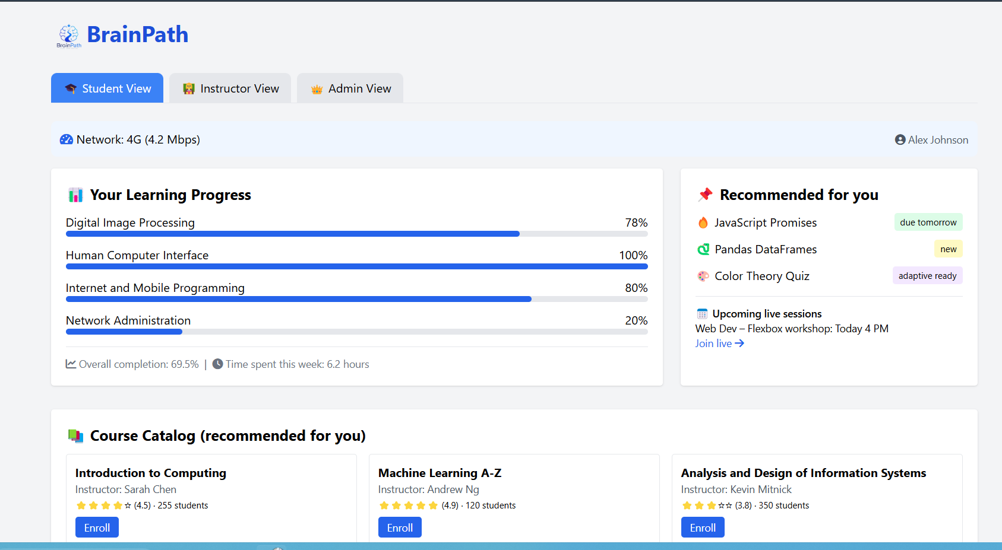
Figure 1: Student dashboard showing enrolled courses and QoE status indicator
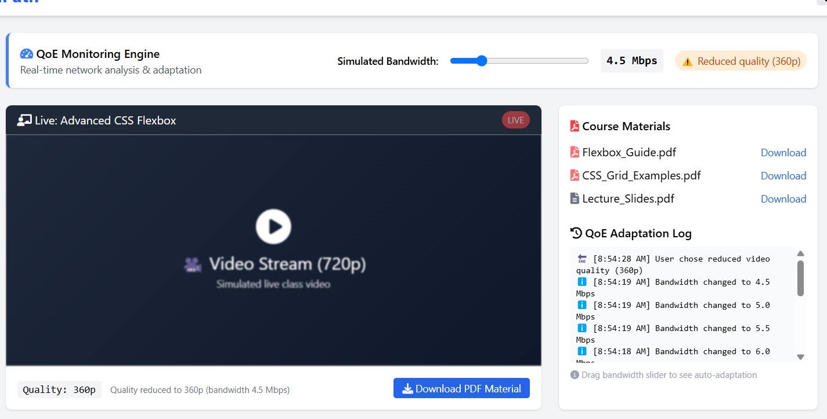
Figure 2: Course view with adaptive content player and QoE banner

5.2 Instructor Interface
The instructor interface enables course creation and management:

- Dashboard — summary of courses taught, enrolled students, and recent submissions.
- Course Management — create, edit, and archive courses; manage sections and materials.
- Upload Content — supports video (MP4), audio (MP3), and document (PDF) uploads with progress tracking.
- Student Progress — tabular view of completion rates, quiz scores, and last access timestamps.
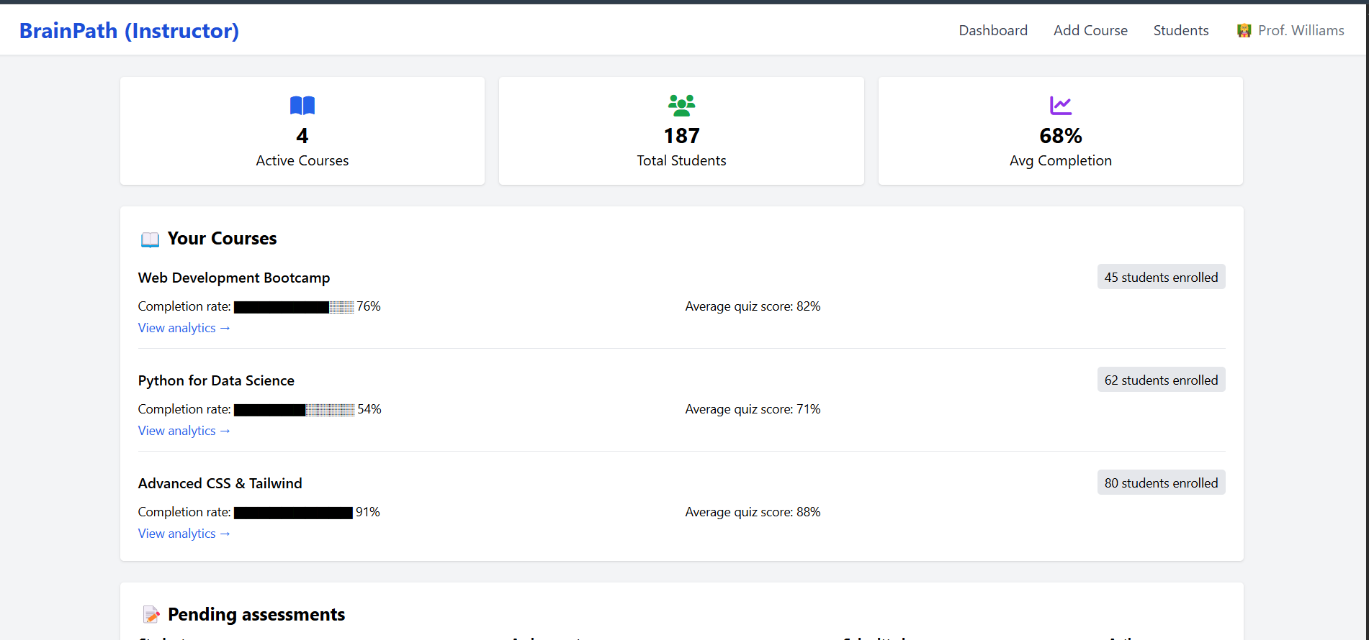

Figure 3: Instructor course management page

5.3 Administrator Interface
The administrator interface provides system oversight and configuration:
- Dashboard — platform-wide statistics: total users, active sessions, average QoE score.
- User Management — all registered users with role assignment, activation/deactivation, and search.
- Adaptive Settings — configurable QoE thresholds for content format switching.
- Reports — stub page prepared for backend integration with usage and QoE analytics.

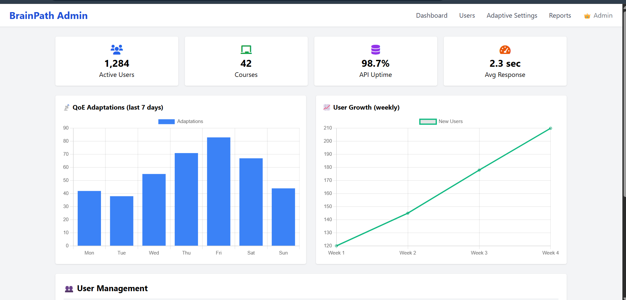
Figure 4: Administrator adaptive settings showing QoE threshold configuration

6. QoE Monitoring Service
The QoE monitoring service (qoeMonitor.js) is the technical core of BrainPath's adaptive capability. It operates silently in the background and provides live network quality data to the rest of the application through QoEContext.

6.1 Passive and Active Hybrid Approach
A hybrid monitoring approach was adopted after evaluating two alternatives:
- Passive monitoring (continuous): The PassiveMonitor class polls navigator.connection every 5 seconds, reading effectiveType (2G/3G/4G), downlink (Mbps), and rtt (ms). Battery Status API is read simultaneously. Near-zero overhead as no network requests are initiated.
- Active monitoring (intermittent): An HTTP speed test fires every 45 seconds by downloading a small payload. Provides a precise throughput measurement correcting drift in passive readings. The 45-second interval balances accuracy against data consumption.

A persistent WebSocket connection for continuous telemetry was evaluated and deferred. The browser-based passive approach eliminates the need for a server connection for basic adaptation, reserving bandwidth for content. WebSocket telemetry will be introduced when the backend is integrated in Task 6.

6.2 QoE Engine — Adaptation Rules
The QoEEngine class processes collected metrics and applies the following rule set:

Condition | Adaptation Action
Bandwidth > 6 Mbps | 720p video (full quality)
Bandwidth 3–6 Mbps | 360p video (reduced quality)
Bandwidth 1.5–3 Mbps | Audio only (video disabled)
Bandwidth < 1.5 Mbps | Text only (all media disabled)
Battery < 20% and not charging | Audio only (regardless of bandwidth)

Thresholds are hard-coded in the frontend but exposed in the Admin Adaptive Settings page, prepared to accept updated values from the backend in Task 6. Adaptation is instantaneous and client-side with no server round-trip required.

6.3 ContentPlayer and QoEBanner
ContentPlayer receives the current QoE state from QoEContext and renders the appropriate element: an HTML5 video player, audio player, or scrollable text transcript. Switching is seamless and preserves playback position where possible. QoEBanner renders a non-intrusive notification when adaptation is active, and disappears automatically when conditions recover.

7. UI Design Decisions
The BrainPath interface was designed with the following principles from the Task 2 survey findings:

Design Principle | Implementation
Mobile-first layout | All pages use a mobile-first Tailwind CSS grid. Sidebars collapse to bottom navigation on small screens. No horizontal scrolling on any page.
Low visual complexity | Minimal two-colour palette (teal primary, white/light-grey surface) to reduce rendering load on low-end devices and keep the interface readable on small screens.
Offline state awareness | All pages display a clear offline banner when no connection is detected. Downloaded content remains accessible and is visually distinguished from online-only content.
Accessible typography | Minimum font size 14px throughout. All interactive elements meet WCAG AA contrast ratios. Form inputs are large enough for reliable touch on small screens.
Minimal data on load | Dashboards load lightweight JSON summaries first; media is only requested on user action. Lazy loading applied to all images and thumbnails.

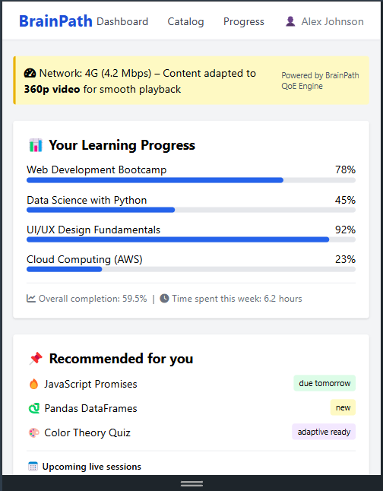
Figure 5: Mobile-responsive student dashboard at 375px viewport width

8. Challenges and Resolutions
Challenge | Resolution
Network monitoring without excessive overhead | Adopted passive + active hybrid: navigator.connection for continuous low-cost polling, intermittent HTTP speed tests for precision. Avoids constant server connections.
Instant adaptation without server round-trip | QoE engine runs entirely client-side. Adaptation decisions are made locally in milliseconds, critical when the connection is already degraded.
Offline content access for downloaded PDFs | Download buttons provided on all content pages. Full IndexedDB-based offline storage for video/audio deferred to Task 6 due to complexity.
Windows script compatibility | The generator script (generate-brainpath.sh) documented for Git Bash on Windows. PowerShell alternative prepared as fallback.
Consistent design across three role interfaces | Shared RoleLayout component and single Tailwind config ensure consistent spacing, colour, and typography across all roles.

9. Deliverables
The following deliverables were produced during Task 5:

- Complete React + Tailwind CSS frontend codebase (App.jsx, contexts, layouts, pages, components, services)
- QoE monitoring module — qoeMonitor.js with PassiveMonitor and QoEEngine
- Adaptive ContentPlayer component with video/audio/text switching and QoEBanner notification
- Project generator script — generate-brainpath.sh, creates the full project in one command
- Design documents — page descriptions, low-fidelity wireframes, and component hierarchy

10. Next Steps (Task 6)
The following items are planned for Task 6 (Database Design and Implementation, Weeks 11–12):

- Define the complete database schema for users, courses, content, enrolments, assessments, progress, and QoE logs.
- Implement the backend API (Node.js/Express or Django) connected to PostgreSQL on Supabase.
- Replace all mock API handlers in the frontend with real endpoint calls.
- Implement the active bandwidth test endpoint (/api/speedtest.bin) for precision QoE measurement.
- Introduce WebSocket-based QoE telemetry streaming between the mobile client and server-side QoE Service.
- Extend offline support using IndexedDB for downloaded video and audio content.
- Begin user acceptance testing of QoE adaptation on real mobile networks (2G, 3G, 4G, poor WiFi).

11. Conclusion
All requirements for Task 5 have been successfully met. The BrainPath frontend is fully functional, with role-based access control for students, instructors, and administrators, an integrated QoE monitoring and adaptive content delivery engine, and a complete navigable interface built with React.js and Tailwind CSS. The application runs locally with a single command and is structured for straightforward backend integration in Task 6. The work was completed within the Weeks 9–10 timeframe with comprehensive documentation and an automated project generator script.

References
1. CEF440 Project Brief. (2025). Design and Implementation of an Adaptive E-learning Platform. University of Buea.
2. React Documentation. (2024). React — The library for web and native user interfaces. https://react.dev
3. Tailwind CSS Documentation. (2024). Utility-First CSS Framework. https://tailwindcss.com/docs
4. MDN Web Docs. (2024). Network Information API. https://developer.mozilla.org/en-US/docs/Web/API/NetworkInformation
5. MDN Web Docs. (2024). Battery Status API. https://developer.mozilla.org/en-US/docs/Web/API/Battery_Status_API
6. Requirement Gathering Survey Results. (2025). Task 2 Deliverable. CEF440 Group, University of Buea.

